Tracking Poverty Across Groupings:
Insights from the World Bank’s Poverty Aggregate Dashboard
Nishant Yonzan, Zander Prinsloo, Jing Xie, Kayley Ashlynn Watsc, Martha Celmira Viveros Mendoza, Christoph Lakner
Are poverty rates decreasing in all regions or income groups? Are they changing at the same rate? What are the regional impacts of recent crises, such as the COVID-19 pandemic and the Russia’s Invasion of Ukraine, on poverty?
The Poverty and Inequality Platform (PIP) provides quick access to the World Bank’s estimates of poverty, inequality, and shared prosperity. The estimates of PIP are based on country-level household data that use either consumption or income welfare aggregates, offering the most complete collection of poverty headcount estimates derived directly from household surveys.
The new PIP Poverty Aggregate Dashboard (Add Link) offers an interactive visualization that presents poverty statistics for various groups that are not currently reported on the PIP but are frequently used in reports and analyses. The Dashboard uses the latest release of PIP data (September 2025) and applies the 2021 Purchasing Power Party (PPPs).
The dashboard presents both the poverty rate and the number of people living in poverty using three global poverty lines: $3.00, $4.20, and $8.20. Users can explore poverty indicators across four key groupings: (i) Geographic Region; (ii) World Bank Income Groups; (iii) World Bank Fragility Classification (FCV); and (iv) International Development Association (IDA) Eligibility Status.
This blog provides guidance on how to use the dashboard and briefly describes its charts. Users can view and download a range of figures and tables, as well as the data underlying the visualizations by selecting their groupings or specific categories within each grouping.
Changes in World Bank Group Regional Classification
With the September 2025 update, PIP’s geographical regions now align with the World Bank’s official regional classification. Compared to earlier definitions, two key changes were introduced.
First, PIP previously excluded some high-income economies from regional aggregates and placed them into a separate group called “Other High-income”. This grouping no longer exists, and these countries were reassigned to their respective regions. Additionally, a new North America region now appears for Canada and United States.
Second, this updated regional groupings reflected the recent reclassification of Afghanistan and Pakistan from South Asia to Middle East & North Africa region. Due to this reclassification, the Middle East & North Africa region has been renamed Middle East, North Africa, Afghanistan & Pakistan.
Compare Poverty Headcount and the Number of Poor within Selected Grouping
The first tab allows users to select a group, specific categories within the selected group, and poverty line (in 2021 PPP) to visualize historical poverty trends. The left panel presents poverty headcount ratio, and the right panel presents the number of poor by region for the selected input.
For example, the chart below shows both poverty indicators using the extreme poverty line by region with new regional classification. We can observe a drastic decline in poverty rate in East Asia and Pacific with both indicators and Sub-Saharan Africa continues to have the highest poverty rate and the largest number of people living in poverty.
Figure 1. Poverty Indicators by New Regional Classification
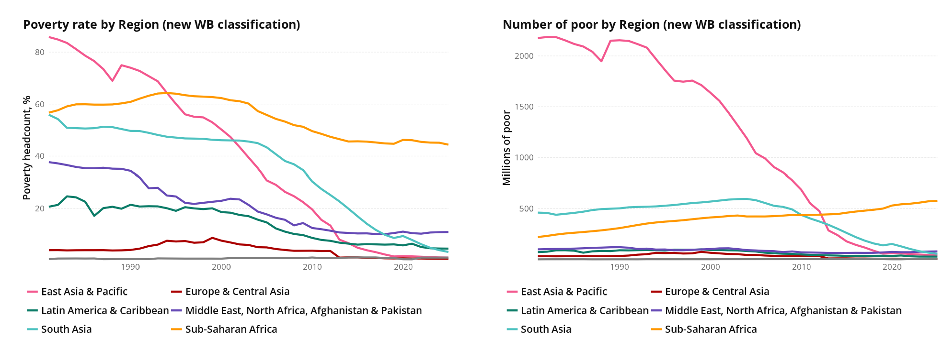
Source: Poverty and Inequality Platform (September 2025, World Bank Group)
Overlay Two Trends from Any Grouping to Reveal Differences Over Time
The second tab allows users to customize the panel by choosing two trends from any groupings and visualize divergences in trends over time. This chart could be especially useful to understand the impact of the new regional groupings on the trends of aggregate poverty indicators and differences in trend with historical or latest definitions in income, FCV, and IDA grouping.
For instance, the chart panel below shows impacts on extreme poverty rate and the population living in extreme poverty after Afghanistan and Pakistan were added to the Middle East and North Africa group. In the chart, Line A represents values with new grouping, while Line B represents old groupings. This chart shows an increase in both poverty indicators under the new grouping.
Figure 2. Changes in Poverty Indicators by Region: Middle East and North Africa
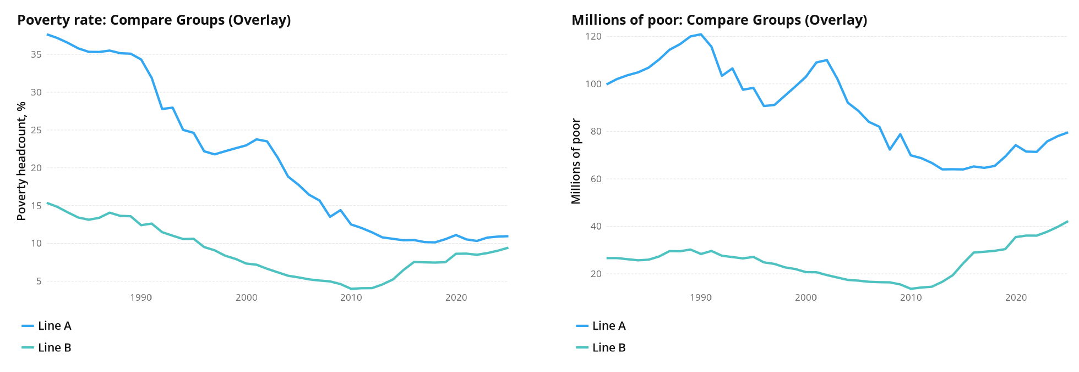
Source: Poverty and Inequality Platform (September 2025, World Bank Group)
An opposite trend was observed in South Asia as Pakistan and Afghanistan left the region. Both poverty rate and millions of poor decreased with the new regional grouping.
Figure 3: Changes in Poverty Indicators by Region: South Asia
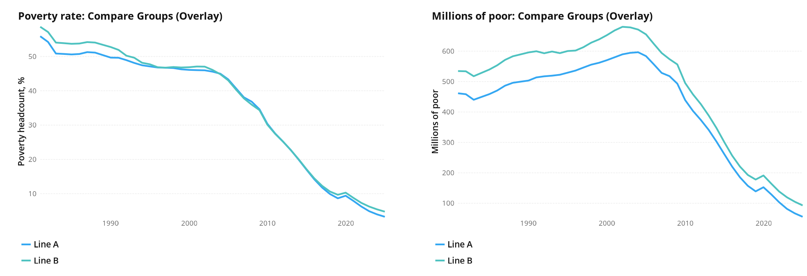
Source: Poverty and Inequality Platform (September 2025, World Bank Group)
Examine Group Patterns with Side-by-Side Panels
The last tab allows users to visualize poverty rate trends in two different groupings at once. Users can choose to visualize poverty rate trajectories with latest and historical definitions or with two completely different groups.
For instance, the charts below present aggregated poverty rate by income groups and fragility status. These charts show that upper-middle-income countries and those not classified as FCV states experienced the highest level of reduction in extreme poverty rate.
Figure 4. Poverty Rate Trajectory: Income Group vs. FCV
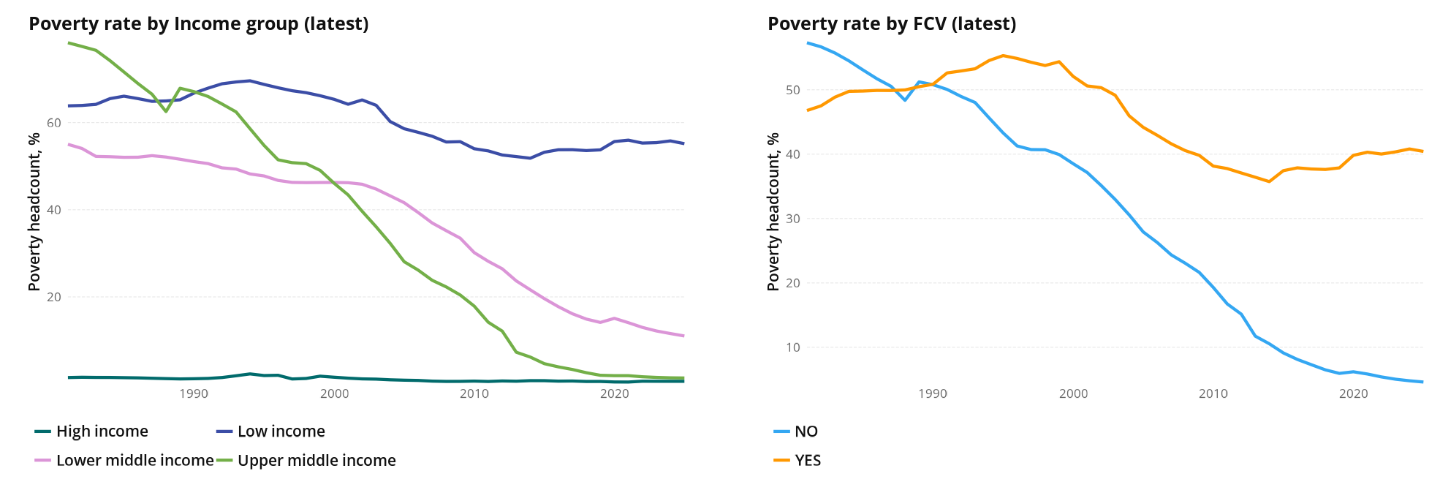
Source: Poverty and Inequality Platform (September 2025, World Bank Group)
The PIP Poverty Aggregate Dashboard (Add Link) provides an interactive visualization of aggregate poverty indicators across four groupings used frequently in policy analysis and academic reports: Region; Income; FCV; and IDA status. This dashboard allows users to compare poverty indicators within selected groups, overlay two trends from any grouping, and examine patterns using side-by-side panel.
More information on its visualizations and the definitions of important indicators can be found in the “About” page of the dashboard. The PIP Methodological Handbook contains additional technical details on the indicators.
We would like to invite all potential users to explore the dashboard and engage in important discussions on aggregate poverty. If you have suggestions or notice anything missing, we encourage you to help us improve by contacting us at pip@worldbank.org.

